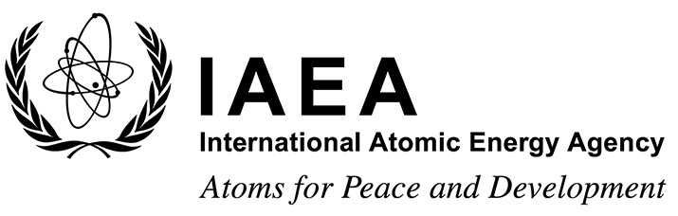 |  |  | Form A  EVT1804519
Participation Form
Technical Meeting on the application of generic models for use in assessing the impact of discharges of radioactive substances to the environment
IAEA Headquarters, Vienna, Austria
20 to 24 July 2020
To be completed by the participant and sent to the competent national authority (e.g. Ministry of Foreign Affairs, Permanent Mission to the IAEA, or National Atomic Energy Authority) of his/her country for subsequent transmission to the International Atomic Energy Agency (IAEA) either by email to: Official.Mail@iaea.org or by fax to: +43 1 26007 (no hard copies needed). Please also send a copy by email to the Scientific Secretary T.Yankovich@iaea.org and to the Administrative Secretary C.Halsall@iaea.org.
Participants who are members of an invited organization can submit this form to their organization for subsequent transmission to the IAEA.
Deadline for receipt by IAEA through official channels: 22 May 2020
Family name: (e.g. Smith) |  | First name(s): (e.g. John) |  | Mr/Ms
Institution:

Full address:

Tel. (Fax):

Email:

Nationality: | Representing following Member State/non-Member State/entity or invited organization:

