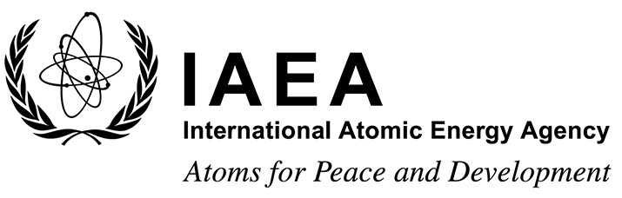 |  |  | Form C  EVT1804519
Grant Application Form
Technical Meeting on the application of generic models for use in assessing the impact of discharges of radioactive substances to the environment
IAEA Headquarters, Vienna, Austria
20 to 24 July 2020
To be completed by the participant and sent to the competent national authority (e.g. Ministry of Foreign Affairs, Permanent Mission to the IAEA, or National Atomic Energy Authority) of his/her country for subsequent transmission to the International Atomic Energy Agency (IAEA) either by email to: Official.Mail@iaea.org or by fax to: +43 1 26007 (no hard copies needed). Please also send a copy by email to the Scientific Secretary T.Yankovich@iaea.org and to the Administrative Secretary C.Halsall@iaea.org.
Deadline for receipt by IAEA through official channels: 22 May 2020
Family name: (e.g. Smith) |  |  |  | First name(s): (e.g. John) |  |  | Mr/Ms:
Mailing address: |  |  |  |  | Tel.:
 |  |  |  |  | Fax:
 |  |  |  |  | Email:
Date of birth (yyyy/mm/dd): |  |  |  |  | Nationality:
- Education (post-secondary):

Name and place of institution |  | Field of study |  |  | Diploma or Degree | Years attended  from to
- Recent employment record (starting with your present post):

Name and place of employer/ organization |  | Title of your position |  |  | Type of work | Years attended  from to
- Description of work performed over the last three years:

- Institute’s/Member State’s programme in field of event:

Date: ___________________ | Signature of applicant: ___________________________
Date: ___________________ | Name, signature and stamp of Ministry of Foreign Affairs, Permanent Mission to the IAEA or National Atomic Energy Authority  _______________________________________________

